TERRAFORM CHALLENGE-01
Write a code using Terraform that deploys and achieves the following:-
1. Create an EC2 Instance on AWS Cloud using the below-mentioned ubuntu AMI and
instance_type. Or, (You can use of your choice as well) ami =
"ami-0461b1436c9b3c1a3" instance_type = "t2.micro"
Lets create a folder called challenge and create a file called main.tf
provider "aws" {
region = "us-east-1"
}
resource "aws_instance" "ec2" {
ami = "ami-0eb38b817b93460ac"
instance_type = "t3.micro"
subnet_id = "subnet-06570a3e32a4110d8"
associate_public_ip_address = "true"

tags = {
Name = "Terraform-EC2"
}
}

}
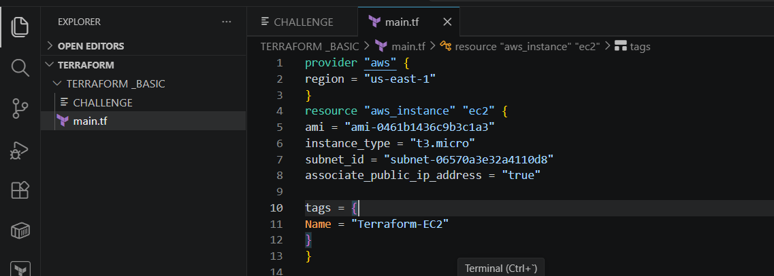
Terraform init
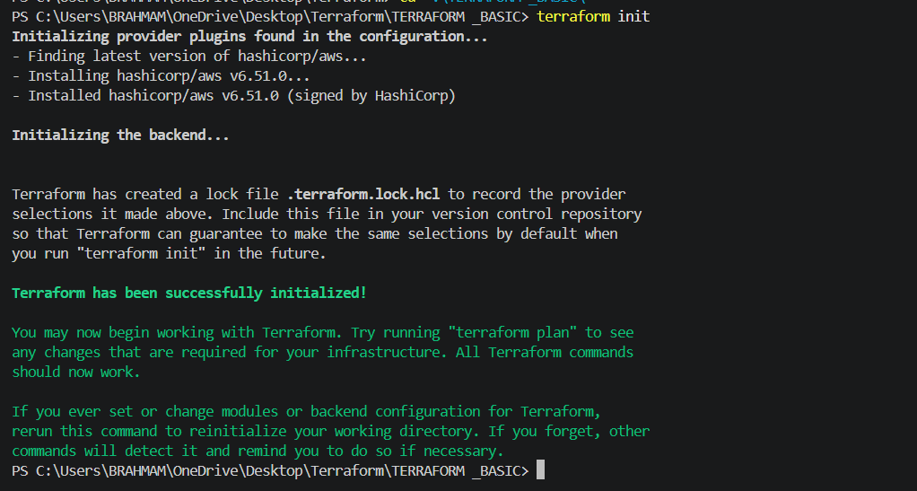
Terraform planterraform apply
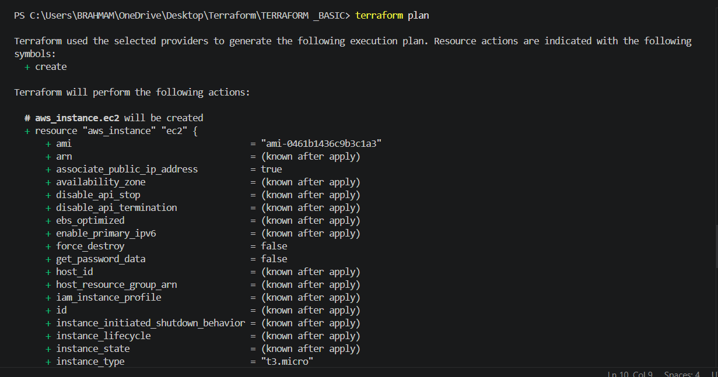
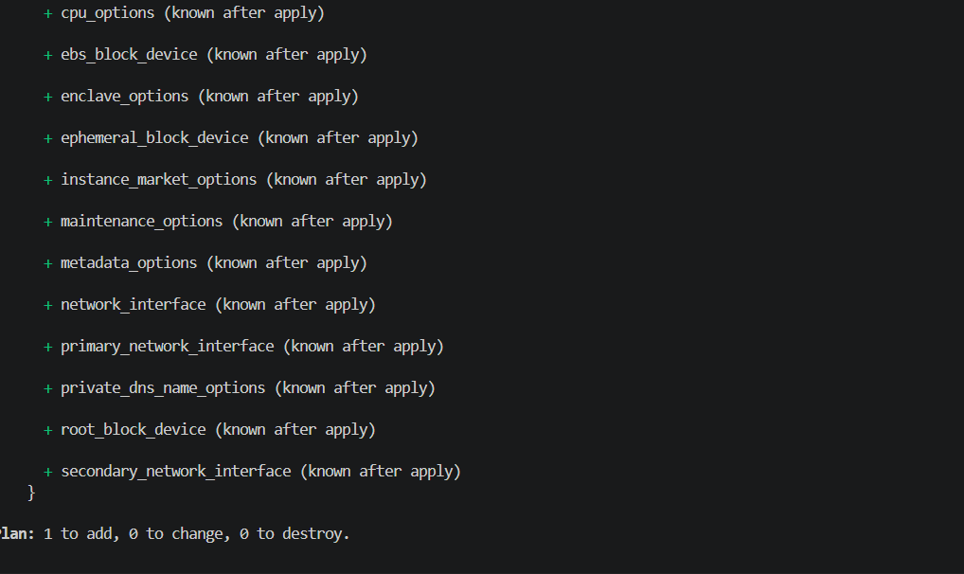
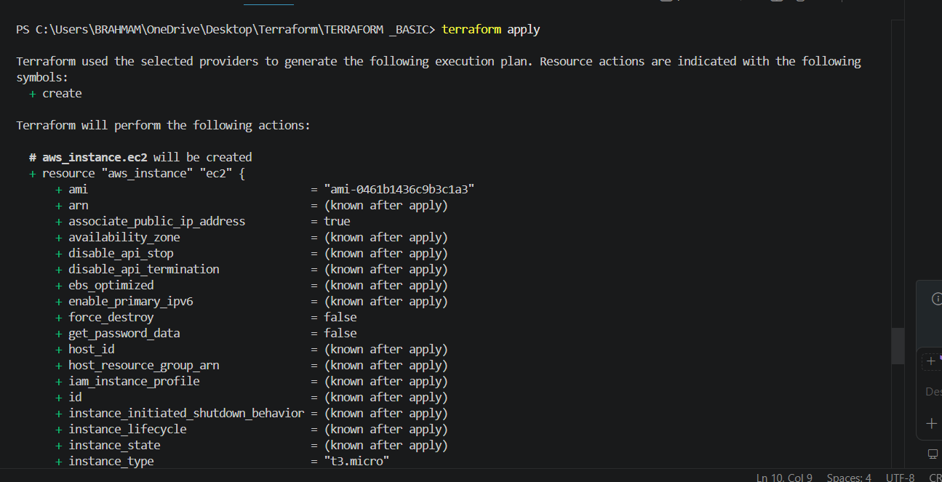
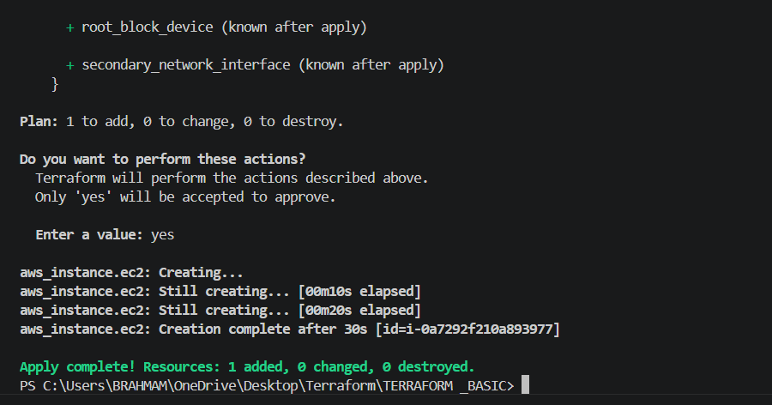
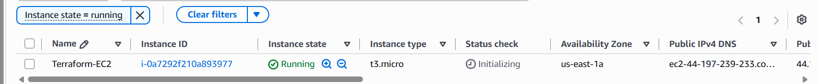
Instance created successfully
2. Install a web server on the same EC2 Instance. The web server should listen on port 8080.
In the same main.tf file which we create earlier we are going to add a resource block for security
groups and we will create and user data for installing nginx while creating a ec2 instance
RESOURCE BLOCK FOR SECURITY GROUPS(This can be optional has our vpc has default
sg where all the ports are open).
resource "aws_security_group" "web_sg" {
name = "web-security-group"
ingress {
description = "SSH Access"
from_port = 22
to_port = 22
protocol = "tcp"
cidr_blocks = ["0.0.0.0/0"]
}
ingress {
description = "Web Server Port"
from_port = 8080
to_port = 8080
protocol = "tcp"
cidr_blocks = ["0.0.0.0/0"]
}
egress {
from_port = 0
to_port = 0
protocol = "-1"
cidr_blocks = ["0.0.0.0/0"]
}
}
This code is creating a security group in AWS called web-security-group.It decides who is allowed
to connect to the server and what kind of traffic can go in or out.
The first ingress rule opens port 22 for SSH access and 8080 for whether the nginx web server is
running or not. This lets you log into your EC2 instance remotely from your computer. Since the IP
range is 0.0.0.0/0, it means anyone on the internet can try to access that port.
The egress rule allows the EC2 instance to send traffic out to the internet without restrictions.
USER-DATA
user_data = <<-EOF
#!/bin/bash
# Update packages
sudo apt update -y
# Install nginx
sudo apt install nginx -y
# Create webpage
sudo tee /var/www/html/index.html > /dev/null <<HTML
<h1>Nginx Running on Port 8080</h1>
HTML
# Configure nginx to listen on 8080
sudo tee /etc/nginx/sites-available/default > /dev/null <<EOL
server {
listen 8080;
root /var/www/html;
index index.html;
}
EOL
# Restart nginx
sudo systemctl restart nginx
sudo systemctl enable nginx
EOF
This code is automatically setting up a web server when the EC2 instance starts. First, it updates
the system packages and installs Nginx. Then it creates a simple webpage with the message
“Nginx Running on Port 8080”. After that, it changes the Nginx configuration so the server listens
on port 8080 instead of the default port. Finally, it restarts Nginx and enables it to start
automatically whenever the server reboots.
provider "aws" {
region = "us-east-1"
}
resource "aws_security_group" "web_sg" {
name = "web-security-group"
ingress {
description = "SSH Access"
from_port = 22
to_port = 22
protocol = "tcp"
cidr_blocks = ["0.0.0.0/0"]
}
ingress {
description = "Web Server Port"
from_port = 8080
to_port = 8080
protocol = "tcp"
cidr_blocks = ["0.0.0.0/0"]
}
egress {
from_port = 0
to_port = 0
protocol = "-1"
cidr_blocks = ["0.0.0.0/0"]
}
}
resource "aws_instance" "ec2" {
ami ="ami-0eb38b817b93460ac"
instance_type = "t3.micro"
subnet_id = "subnet-06570a3e32a4110d8"
associate_public_ip_address = true
vpc_security_group_ids = [aws_security_group.web_sg.id]

user_data = <<-EOF
#!/bin/bash
# Update packages
sudo apt update -y
# Install nginx
sudo apt install nginx -y
# Create webpage
sudo tee /var/www/html/index.html > /dev/null <<HTML
<h1>Nginx Running on Port 8080</h1>
HTML
# Configure nginx to listen on 8080
sudo tee /etc/nginx/sites-available/default > /dev/null <<EOL
server {
listen 8080;
root /var/www/html;
index index.html;
}
EOL
# Restart nginx
sudo systemctl restart nginx
sudo systemctl enable nginx
EOF

tags = {
Name ="Terraform-EC2"
}
}
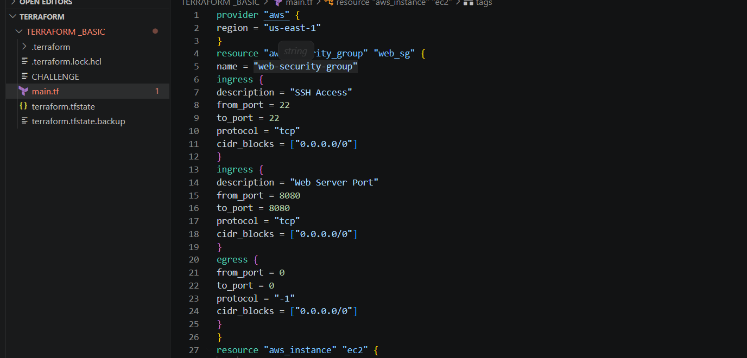
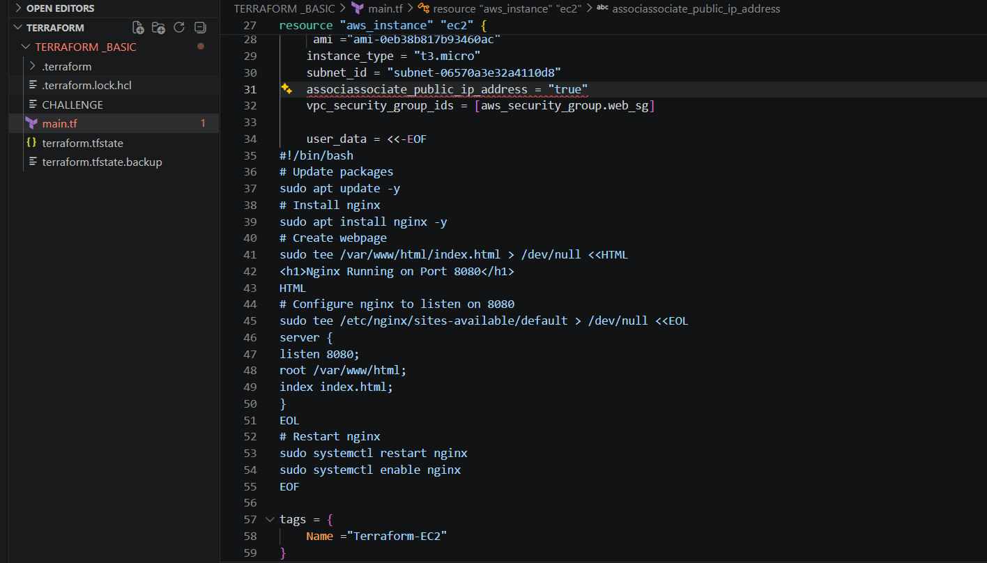
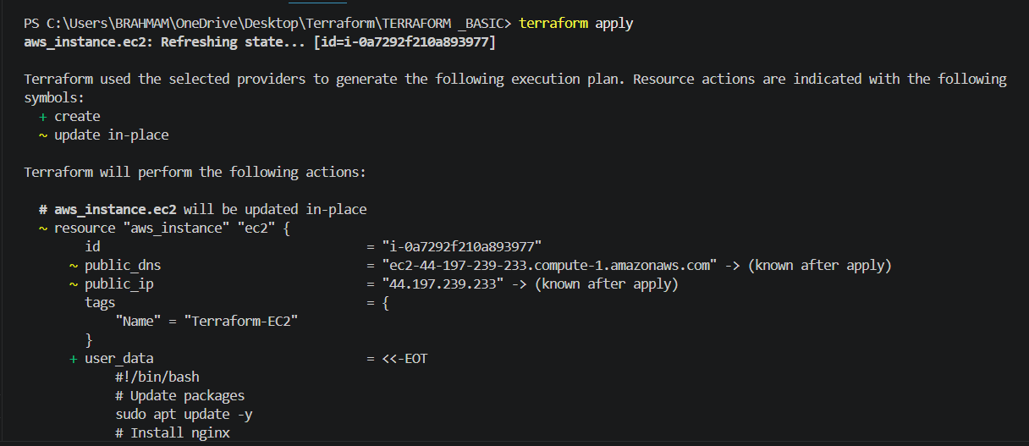
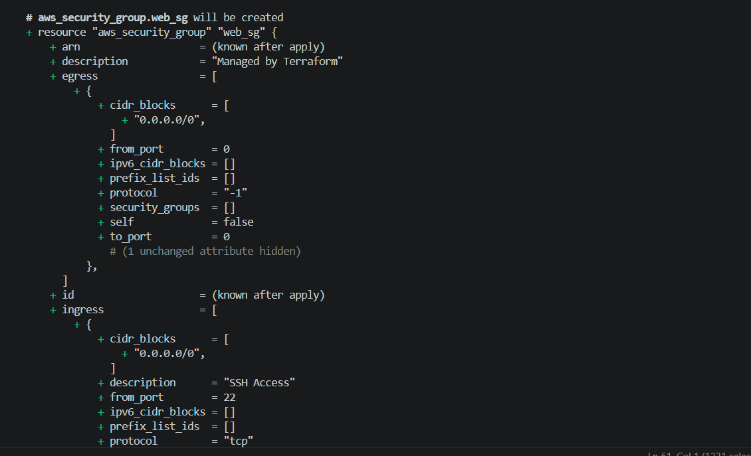
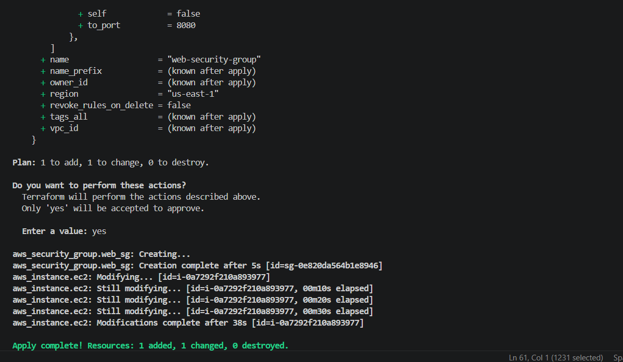
we are able to access the browser
I got error because of my ami is related a,axzon linux but we want to install nginx in ubuntu ami id
After changing the ami of ubuntu image

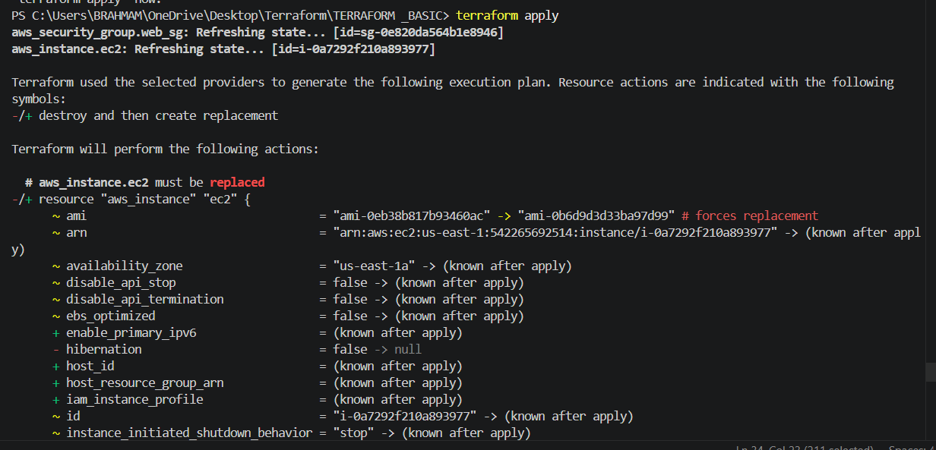
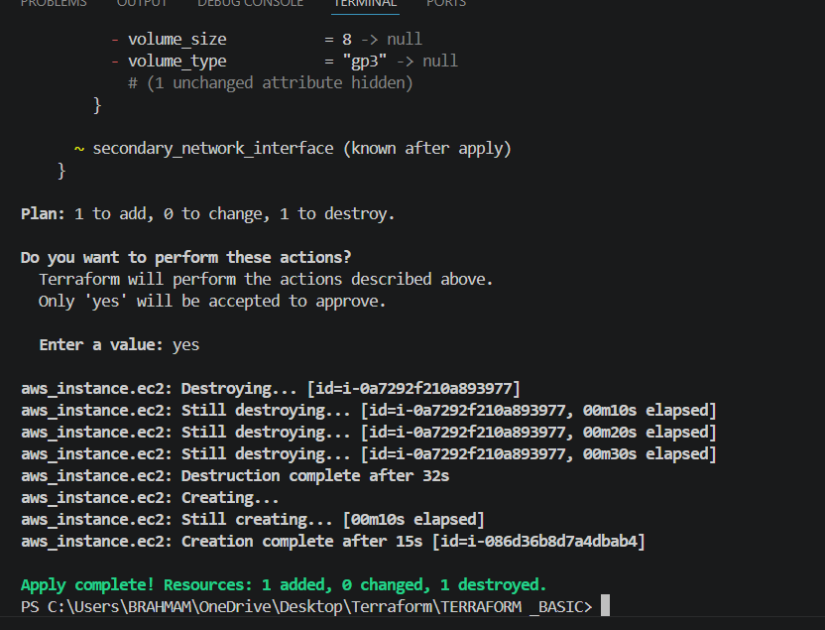
- Successfully running nginx
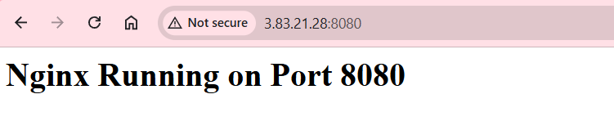
3. Create a Docker-compose file for the
project:https://github.com/betawins/cricbuzz-docker-hello-world.gitand point it to
port 8000.
4.Make the web server point to the above service so that 8080 returns the response
from the Docker service.
This project deploys a Dockerized Hello World web application on an AWS EC2 instance
using Terraform. The setup includes two ways to access the app:
- Port 8000 — Direct access to the Docker container
- Port 8080 — Via Nginx reverse proxy (which forwards to port 8000)
- →main.tf — Main Terraform config. Does everything:
- Creates TLS key pair for SSH access
- Creates a Security Group opening ports 22, 8000, 8080
- Launches an Ubuntu EC2 instance with a user_data bootstrap script that:
o Installs Docker, Docker Compose, Git, Nginx
o Clones https://github.com/betawins/cricbuzz-docker-hello-world.git
o Writes a docker-compose.yml to build and run the app on port 8000
o Configures Nginx on port 8080 to reverse proxy to port 8000
Lets create main.tf file
terraform {
required_providers {
aws = {
source = "hashicorp/aws"
version = "~> 6.0"
}
tls = {
source = "hashicorp/tls"
version = "~> 4.0"
}
local = {
source = "hashicorp/local"
version = "~> 2.0"
}
}
}
provider "aws" {
region = var.aws_region
}
resource "tls_private_key" "cricbuzz_key" {
algorithm = "RSA"
rsa_bits = 4096
}
resource "local_file" "private_key_pem" {
content = tls_private_key.cricbuzz_key.private_key_pem
filename = "${path.module}/cricbuzz-key.pem"
file_permission = "0400"
}
resource "aws_key_pair" "cricbuzz_key" {
key_name = "cricbuzz-key"
public_key = tls_private_key.cricbuzz_key.public_key_openssh
}
resource "aws_security_group" "hello_world_sg" {
name = "cricbuzz-hello-world-sg"
description = "Allow SSH, port 8000 and port 8080"
ingress {
description = "SSH"
from_port = 22
to_port = 22
protocol = "tcp"
cidr_blocks = ["0.0.0.0/0"]
}
ingress {
description = "Docker App Port 8000"
from_port = 8000
to_port = 8000
protocol = "tcp"
cidr_blocks = ["0.0.0.0/0"]
}
ingress {
description = "Nginx Web Server Port 8080"
from_port = 8080
to_port = 8080
protocol = "tcp"
cidr_blocks = ["0.0.0.0/0"]
}
egress {
from_port = 0
to_port = 0
protocol = "-1"
cidr_blocks = ["0.0.0.0/0"]
}
tags = {
Name = "cricbuzz-hello-world-sg"
}
}
locals {
user_data_script = <<SCRIPT
#!/bin/bash
exec > /var/log/user-data.log 2>&1
set -e
sleep 30
apt-get update -y
DEBIAN_FRONTEND=noninteractive apt-get install -y docker.io git curl nginx
systemctl start docker
systemctl enable docker
mkdir -p /usr/local/lib/docker/cli-plugins
curl -SL "https://github.com/docker/compose/releases/latest/download/docker-compose-
linux-x86_64" \
-o /usr/local/lib/docker/cli-plugins/docker-compose
chmod +x /usr/local/lib/docker/cli-plugins/docker-compose
git clone https://github.com/betawins/cricbuzz-docker-hello-world.git /opt/cricbuzz
cat > /opt/cricbuzz/Dockerfile << 'DOCKERFILE'
FROM golang:1.21-alpine AS builder
WORKDIR /app
RUN printf 'package main\nimport(\n"fmt"\n"net/http"\n)\nfunc
main(){\nhttp.HandleFunc("/",func(w http.ResponseWriter,r
*http.Request){\nfmt.Fprintln(w,"Hello World!")\n})\nhttp.ListenAndServe(":8000",nil)\n}' >
main.go
RUN go build -o hello_world main.go
FROM alpine:latest
WORKDIR /app
COPY --from=builder /app/hello_world .
EXPOSE 8000
CMD ["./hello_world"]
DOCKERFILE
cat > /opt/cricbuzz/docker-compose.yml << 'COMPOSE'
version: '3.8'
services:
cricbuzz:
build: .
ports:
- "8000:8000"
restart: unless-stopped
COMPOSE
cd /opt/cricbuzz
docker compose up -d --build
cat > /etc/nginx/sites-available/cricbuzz << 'NGINX'
server {
listen 8080;
server_name _;
location / {
proxy_pass http://127.0.0.1:8000;
proxy_http_version 1.1;
proxy_set_header Host $host;
proxy_set_header X-Real-IP $remote_addr;
proxy_set_header X-Forwarded-For $proxy_add_x_forwarded_for;
}
}
NGINX
ln -sf /etc/nginx/sites-available/cricbuzz /etc/nginx/sites-enabled/cricbuzz
rm -f /etc/nginx/sites-enabled/default
systemctl restart nginx
systemctl enable nginx
SCRIPT
}
resource "aws_instance" "hello_world" {
ami = var.ami_id
instance_type = var.instance_type
key_name = aws_key_pair.cricbuzz_key.key_name
vpc_security_group_ids = [aws_security_group.hello_world_sg.id]
user_data = base64encode(local.user_data_script)
user_data_replace_on_change = true
tags = {
Name = "cricbuzz-hello-world"
}
}
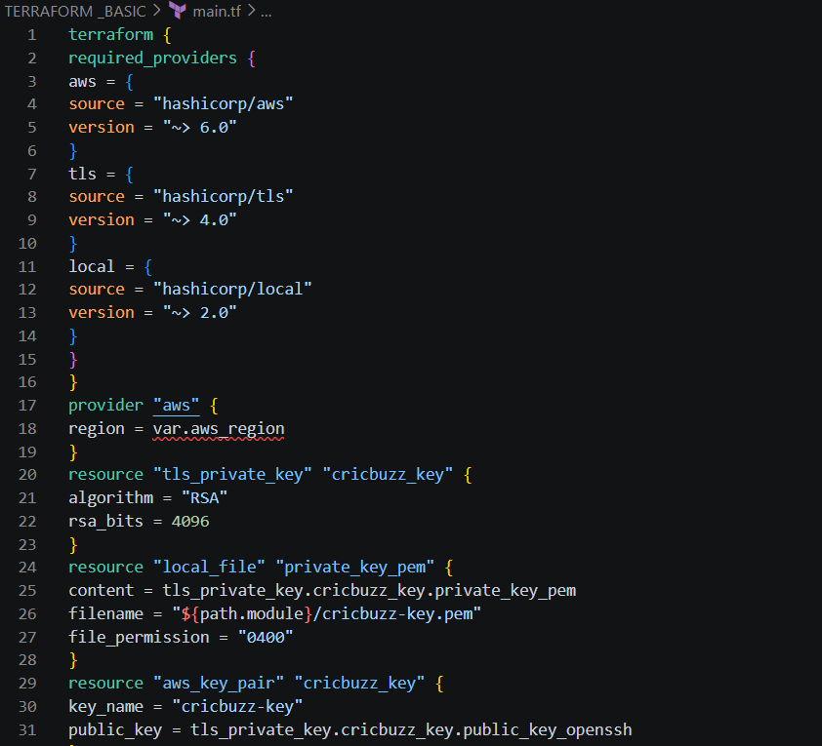
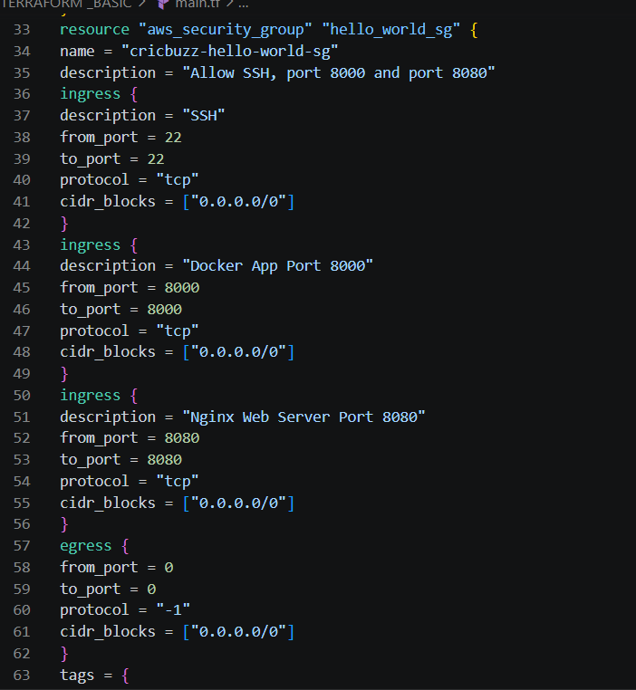
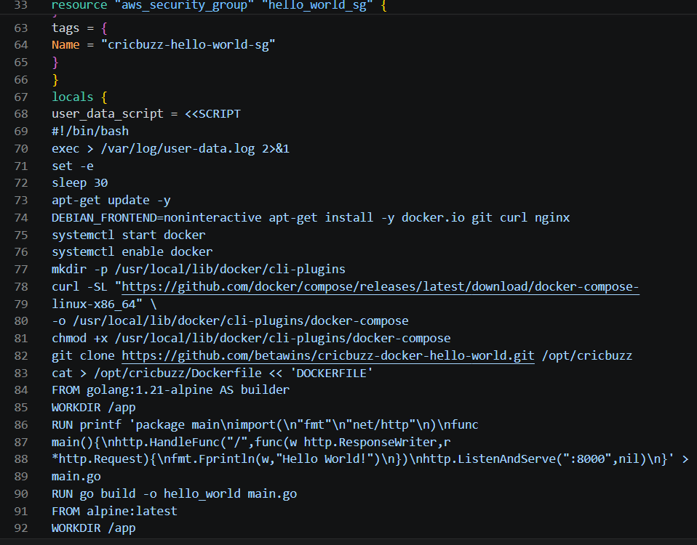
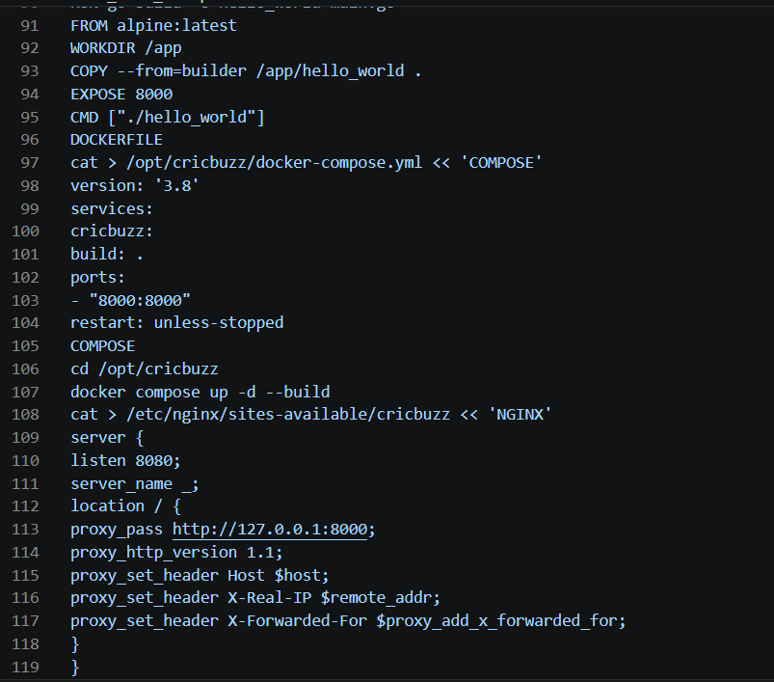
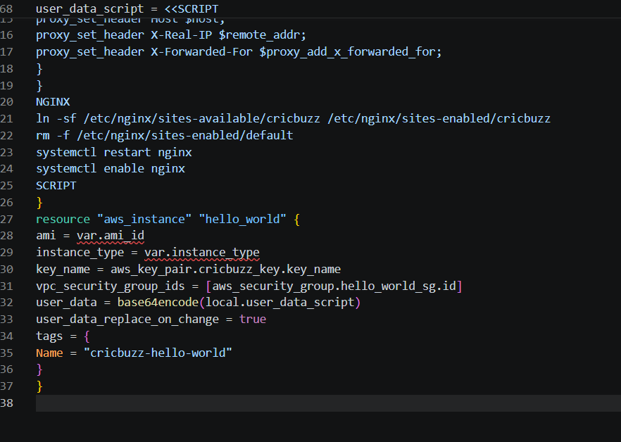
variable.tf
variable "aws_region" {
description = "AWS region to deploy resources"
type = string
default = "us-east-1"
}
variable "ami_id" {
description = "AMI ID for the EC2 instance (Ubuntu 26.04 LTS us-east-1)"
type = string
default = " ami-0b6d9d3d33ba97d99"
}
variable "instance_type" {
description = "EC2 instance type"
type = string
default = "t3.micro"
}
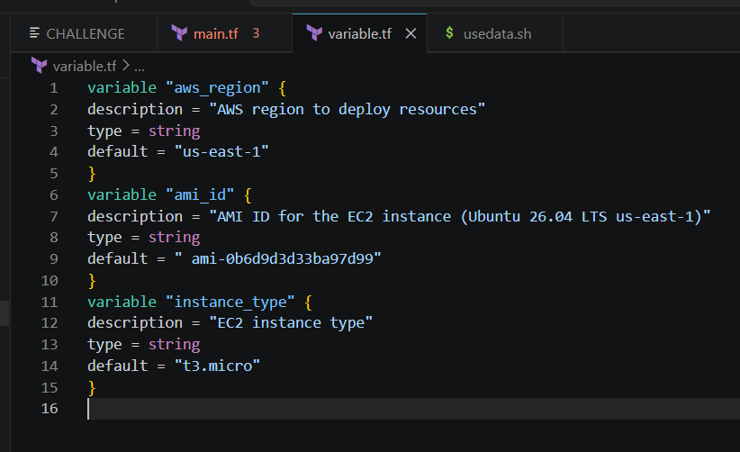
output.tf
output "instance_public_ip" {
description = "Public IP of the EC2 instance"
value = aws_instance.hello_world.public_ip
}
output "instance_public_dns" {
description = "Public DNS of the EC2 instance"
value = aws_instance.hello_world.public_dns
}
output "app_url_8000" {
description = "Direct Docker app URL on port 8000"
value = "http://${aws_instance.hello_world.public_ip}:8000"
}
output "app_url_8080" {
description = "Nginx reverse proxy URL on port 8080"
value = "http://${aws_instance.hello_world.public_ip}:8080"
}
output "ssh_command" {
description = "SSH command to connect to the instance"
value = "ssh -i cricbuzz-key.pem ubuntu@${aws_instance.hello_world.public_ip}"
}
output "key_pair_name" {
description = "Name of the AWS key pair"
value = aws_key_pair.cricbuzz_key.key_name
}
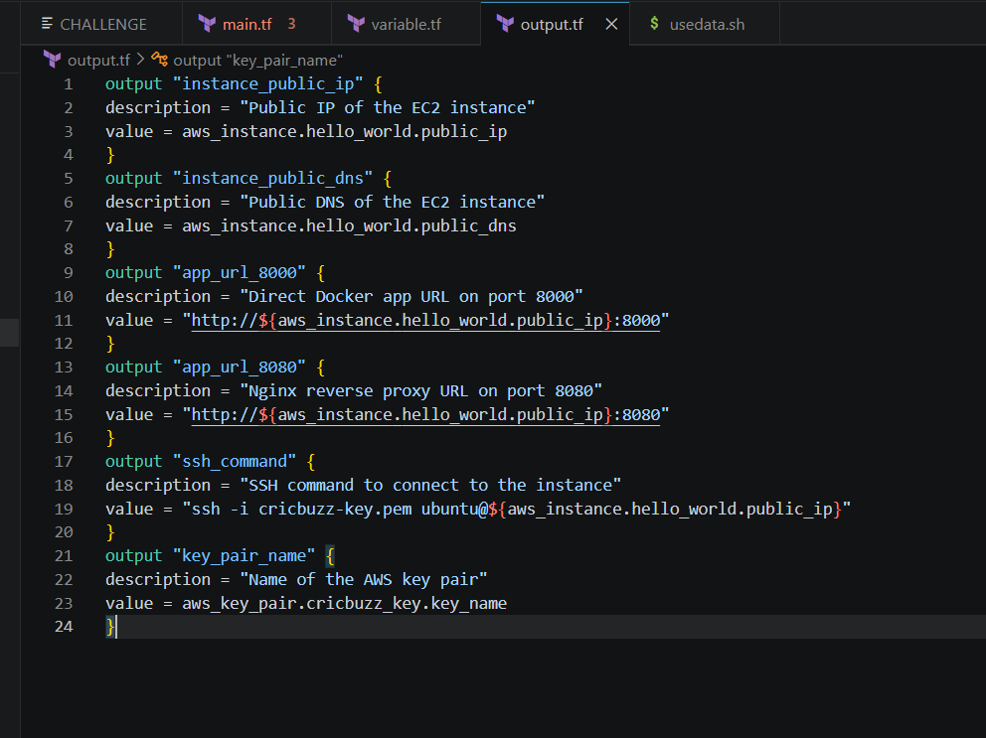
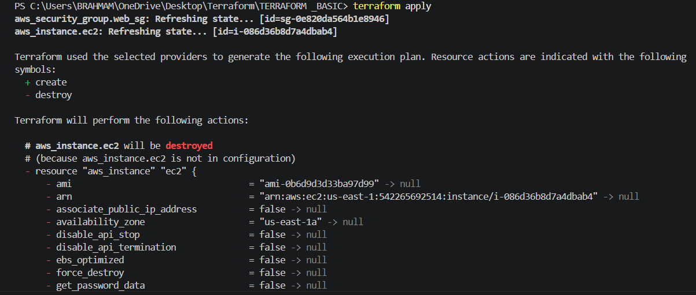
I got error because of my subnet is not mentioned and variables.tf file also not in inside then I cann create another file
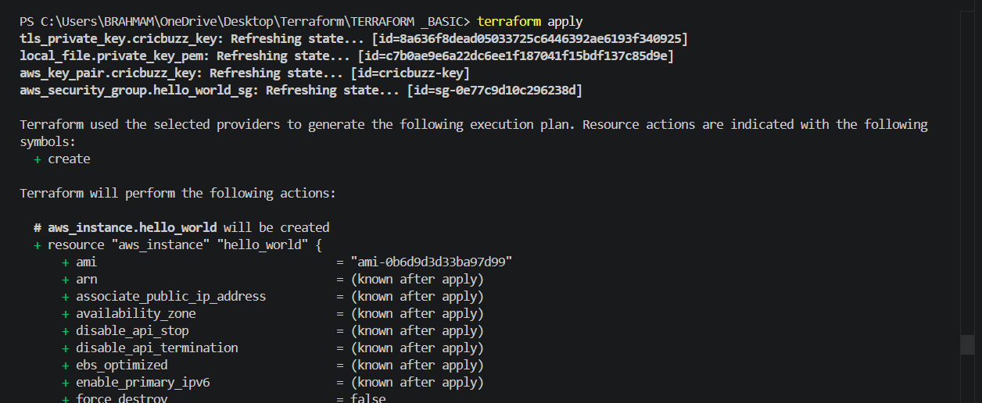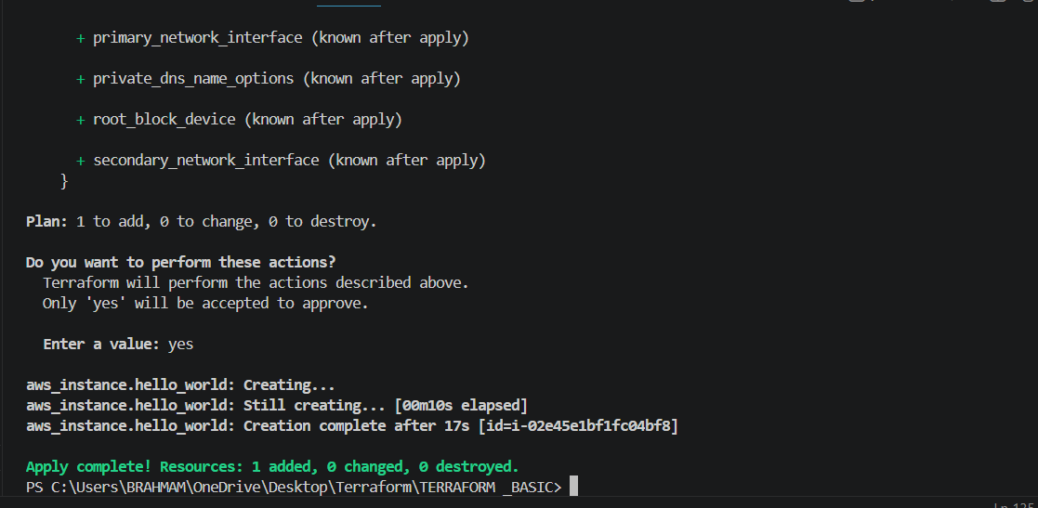
Lets access the browse
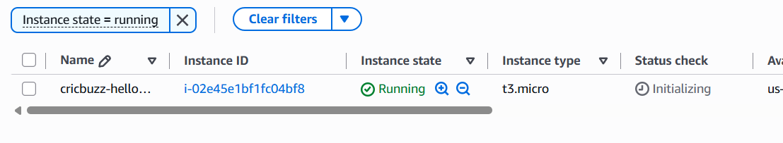
I don’t get public ip for my ec2 instance then I want to give
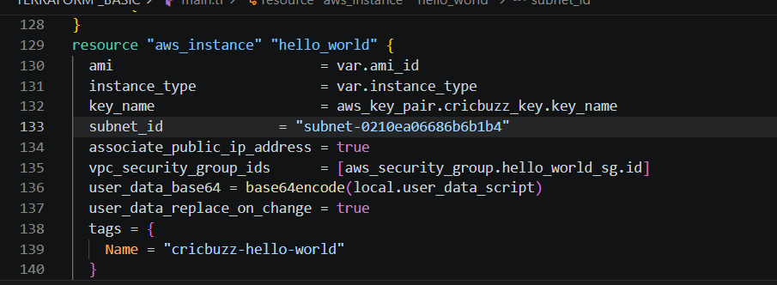
So I agin terraform apply sucesfully running 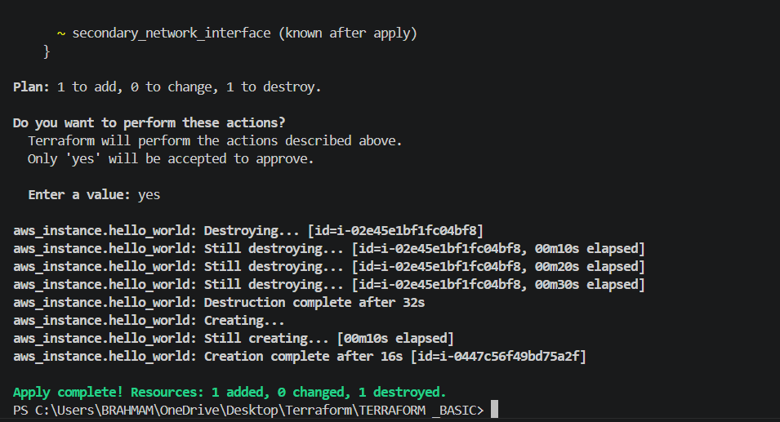
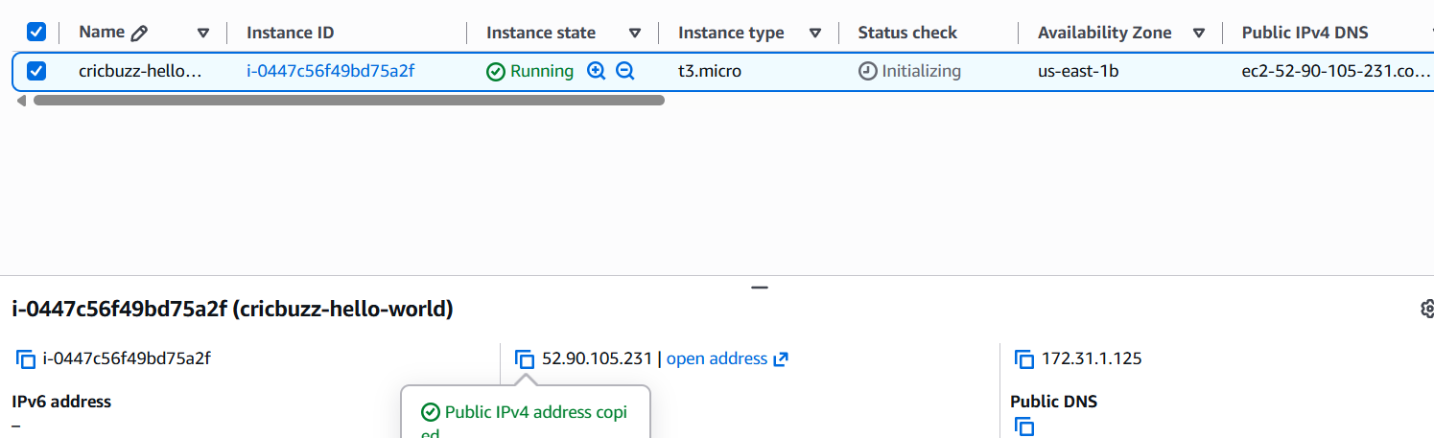

5.Configure to Save the Logs in the location /var/log/cb.log
6.Write the Log rotate configuration for the above file
-Lets add script in main.tf

This script creates a log file for the application and gives the web server permission to write
to it. It then sets up log rotation, which automatically manages the log file by creating a new
log every day, keeping the last 14 days of logs, and compressing old logs to save disk space.
After rotating the logs, it reloads Nginx so that logging continues without interruption.
Finally, it prints a message showing that the setup has completed successfully. This helps
keep logs organized and prevents them from consuming too much storage.
